

# *UniX and Linux Essentials*

**ASSIGNMENT -10**

**SUBMITTED BY:**

**AYUSH KUMAR JHA**

**SAP ID - 500086400**

**Enrollment no - R200220083**

**B.C.A -I.O.T.**

**Assignment 10: -**

1. Umask check and change the default permission

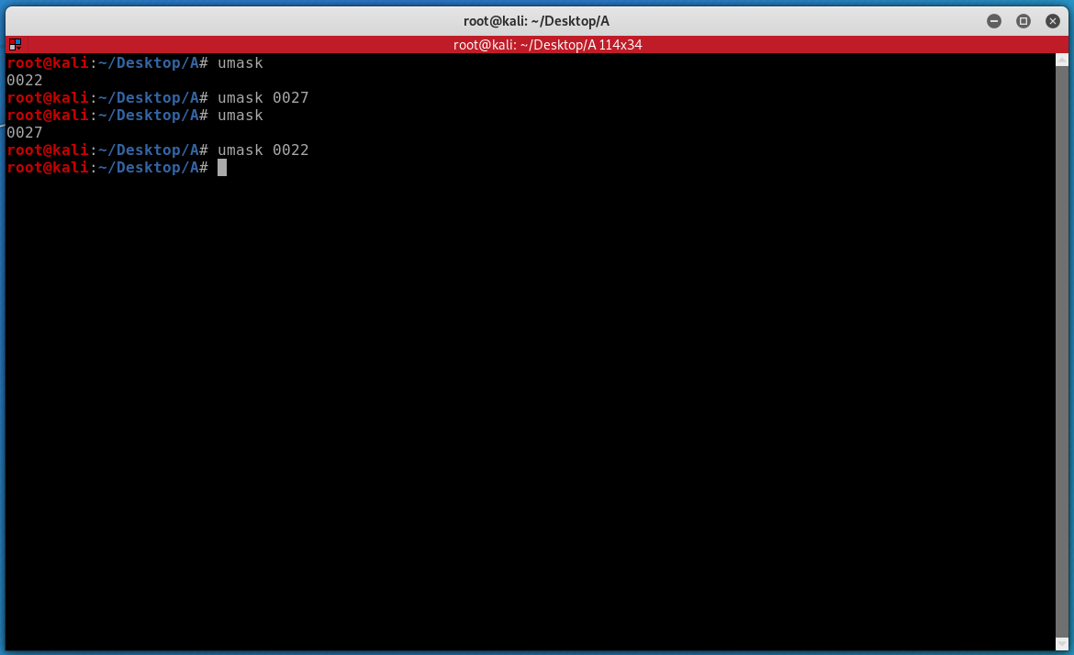

2.Check the change in permission of a file

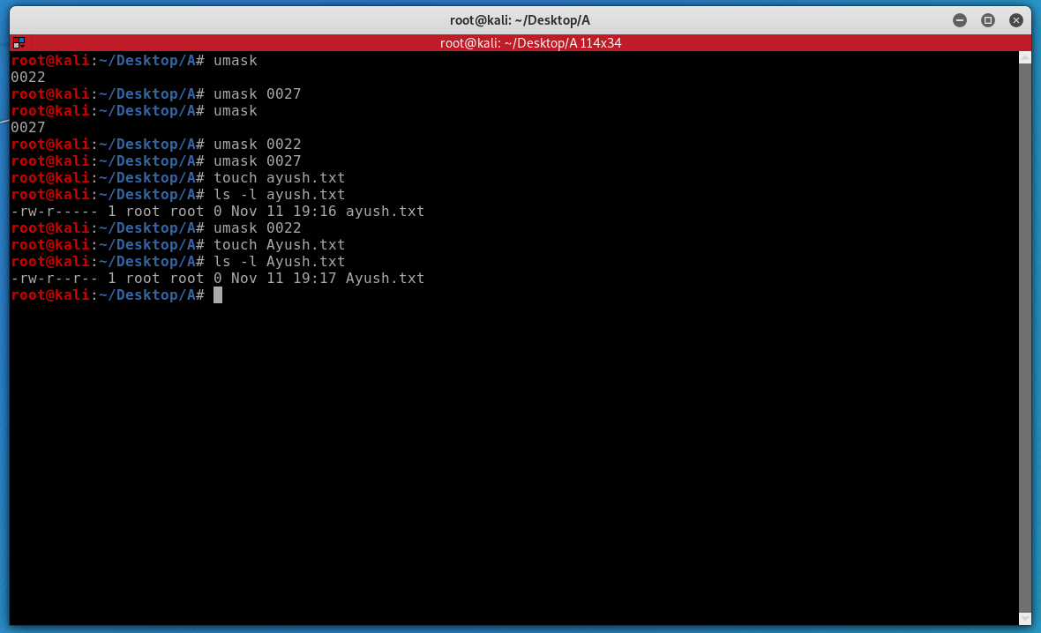

3.Show Default permission

